Assignment no .9
Graph

Course Name : Data Structures-I
Course Code : CS2301
Div : SEDA-B
Student Name : Yashraj Dinesh Hande
Roll Number : 18
Date of Submission : 25/11/2025
Graph
A Graph is a non-linear data structure consisting of vertices (nodes) and edges (connections) that represent relationships between entities.
Graphs can be directed (edges have direction) or undirected, and weighted or unweighted depending on whether edges carry values.
🔹 Graph Representations
- Adjacency Matrix:
  - A 2D array G[i][j] where a non-zero value indicates an edge between vertex i and j.
  - Simple to implement, but uses more space (O(V²)).
- Adjacency List:
  - Uses an array of linked lists; each list represents nodes connected to a vertex.
  - Space-efficient (O(V + E)) and better for sparse graphs.

🔹 Basic Graph Traversal Techniques
- BFS (Breadth-First Search):
  - Explores all neighboring vertices before moving to the next level.
  - Uses a queue.
  - Suitable for shortest path in unweighted graphs.
- DFS (Depth-First Search):
  - Explores as far as possible along one branch before backtracking.
  - Uses a stack or recursion.
  - Useful for pathfinding, connectivity, and cycle detection.

🔹 Minimum Spanning Tree (MST) Algorithms
- Prim’s Algorithm:
  - Builds the MST starting from any vertex, adding the minimum weight edge connecting the tree to a new vertex.
  - Works efficiently with Adjacency List using a priority queue.
  - Time complexity: O(E log V).
- Kruskal’s Algorithm:
  - Sorts all edges by weight and adds them to the MST, avoiding cycles (using Union-Find).
  - Efficient for sparse graphs.
  - Time complexity: O(E log E).

🔹 Shortest Path Algorithm
Dijkstra’s Algorithm:
- Finds the shortest distance from a source node to all other nodes in a weighted, non-negative graph.
- Uses a min-priority queue to select the nearest unvisited vertex.
- Commonly used in routing and navigation systems.

🔹 Applications of Graphs
- Social networks (connections between users)
- Transportation & navigation (shortest route finding)
- Network routing protocols
- Dependency graphs in compilers and project planning

Problem 1: Write a Program to accept a graph from a user and represent it with Adjacency Matrix and perform BFS and DFS traversals on it.

CODE:
#include <iostream>
#include <queue>
#include <vector>
using namespace std;

class Graph {
private:
int vertices;
vector<vector<int>> adjMatrix;
vector<bool> visited;

public:
Graph(int v) {
vertices = v;
adjMatrix.resize(vertices, vector<int>(vertices, 0));
visited.resize(vertices, false);
}
// Function to add an edge
void addEdge(int u, int v) {
adjMatrix[u][v] = 1;
adjMatrix[v][u] = 1; // For undirected graph
}

// Display adjacency matrix
void displayMatrix() {
cout << "\nAdjacency Matrix Representation:\n";
for (int i = 0; i < vertices; i++) {
for (int j = 0; j < vertices; j++)
cout << adjMatrix[i][j] << " ";
cout << endl;
}
}
// BFS traversal
void BFS(int start) {
fill(visited.begin(), visited.end(), false);
queue<int> q;
visited[start] = true;
q.push(start);

cout << "\nBFS Traversal starting from vertex " << start << ": ";
while (!q.empty()) {
int node = q.front();
q.pop();
cout << node << " ";

for (int i = 0; i < vertices; i++) {
if (adjMatrix[node][i] && !visited[i]) {
visited[i] = true;
q.push(i);
}
}
}
cout << endl;
}
// DFS traversal
void DFSUtil(int node) {
visited[node] = true;
cout << node << " ";
for (int i = 0; i < vertices; i++) {
if (adjMatrix[node][i] && !visited[i])
DFSUtil(i);
}
}
void DFS(int start) {
fill(visited.begin(), visited.end(), false);
cout << "\nDFS Traversal starting from vertex " << start << ": ";
DFSUtil(start);
cout << endl;
}
};
// ================= MAIN FUNCTION =================
int main() {
int v, e, u, w, start;
cout << "============================================\n";
cout << " GRAPH REPRESENTATION USING ADJACENCY MATRIX\n";
cout << "============================================\n";
cout << "Enter number of vertices: ";
cin >> v;
Graph g(v);
cout << "Enter number of edges: ";
cin >> e;
cout << "Enter the edges (u v):\n";
for (int i = 0; i < e; i++) {
cin >> u >> w;
g.addEdge(u, w);
}
g.displayMatrix();
cout << "\nEnter starting vertex for BFS and DFS: ";
cin >> start;
g.BFS(start);
g.DFS(start);

return 0;
}

OUTPUT:

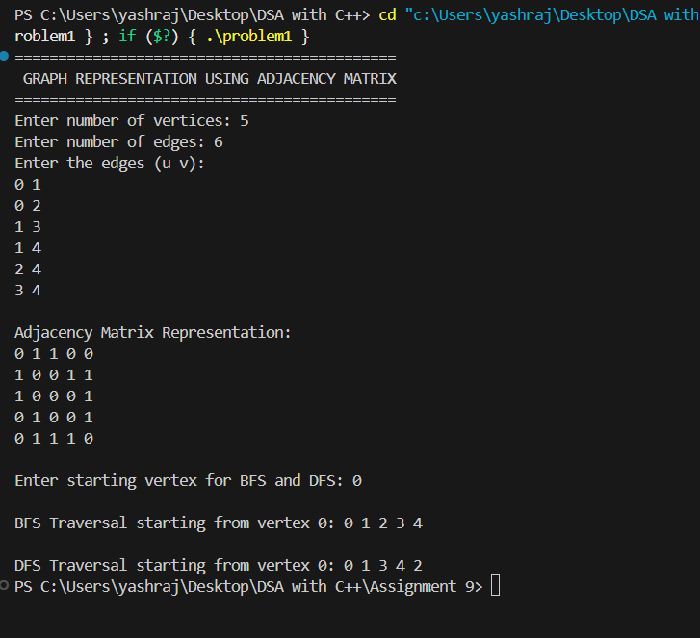

Problem 2: Write a Program to implement Prim’s algorithm to find minimum spanning tree of a user defined graph. Use Adjacency
List to represent a graph.

CODE:
#include <iostream>
#include <vector>
#include <queue>
#include <utility>
using namespace std;

class Graph {
private:
int vertices;
vector<vector<pair<int, int>>> adj; // pair<vertex, weight>

public:
Graph(int v = 0) {
vertices = v;
adj.resize(vertices);
}

void createGraph(int v) {
vertices = v;
adj.clear();
adj.resize(vertices);
cout << " Graph with " << vertices << " vertices created successfully.\n";
}

void addEdge(int u, int v, int w) {
if (u >= vertices || v >= vertices) {
cout << " Invalid vertex number.\n";
return;
}
adj[u].push_back({v, w});
adj[v].push_back({u, w}); // Undirected graph
cout << " Edge added between " << u << " and " << v << " (Weight: " << w << ")\n";
}

void displayGraph() {
cout << "\n Adjacency List Representation:\n";
cout << "---------------------------------\n";
for (int i = 0; i < vertices; i++) {
cout << i << " -> ";
for (auto edge : adj[i])
cout << "(" << edge.first << ", " << edge.second << ") ";
cout << endl;
}
}

void primMST() {
if (vertices == 0) {
cout << " Graph is empty. Please create and add edges first.\n";
return;
}

vector<int> key(vertices, INT8_MAX);
vector<int> parent(vertices, -1);
vector<bool> inMST(vertices, false);

priority_queue<pair<int, int>, vector<pair<int, int>>, greater<pair<int, int>>> pq;

int start = 0;
key[start] = 0;
pq.push({0, start});

while (!pq.empty()) {
int u = pq.top().second;
pq.pop();

if (inMST[u]) continue;
inMST[u] = true;

for (auto edge : adj[u]) {
int v = edge.first;
int weight = edge.second;

if (!inMST[v] && weight < key[v]) {
key[v] = weight;
pq.push({key[v], v});
parent[v] = u;
}
}
}

cout << "\n Minimum Spanning Tree (Prim’s Algorithm):\n";
cout << "-------------------------------------------\n";
int totalWeight = 0;
for (int i = 1; i < vertices; i++) {
cout << parent[i] << " - " << i << " (Weight: " << key[i] << ")\n";
totalWeight += key[i];
}
cout << "-------------------------------------------\n";
cout << "Total Weight of MST: " << totalWeight << endl;
}
};

// ================= MAIN FUNCTION =================
int main() {
Graph g;
int choice, v, u, w;

cout << "=================================================\n";
cout << " MENU DRIVEN PROGRAM — PRIM’S ALGORITHM (MST)\n";
cout << "=================================================\n";

do {
cout << "\n------------- MENU -------------\n";
cout << "1. Create Graph\n";
cout << "2. Add Edge\n";
cout << "3. Display Graph (Adjacency List)\n";
cout << "4. Generate MST using Prim’s Algorithm\n";
cout << "5. Exit\n";
cout << "--------------------------------\n";
cout << "Enter your choice: ";
cin >> choice;

switch (choice) {
case 1:
cout << "Enter number of vertices: ";
cin >> v;
g.createGraph(v);
break;

case 2:
cout << "Enter edge (u v weight): ";
cin >> u >> v >> w;
g.addEdge(u, v, w);
break;

case 3:
g.displayGraph();
break;

case 4:
g.primMST();
break;

case 5:
cout << "Exiting program... Thank you!\n";
break;

default:
cout << "⚠️ Invalid choice! Please try again.\n";
}
} while (choice != 5);

return 0;
}

OUTPUT:

PS C:\Users\yashraj\Desktop\DSA with C++> cd "c:\Users\yashraj\Desktop\DSA with C++\Assignment 9\" ; if ($?) { g++ problem2.cpp -o problem2 } ; if ($?) { .\problem2 }
=================================================
MENU DRIVEN PROGRAM ΓÇö PRIMΓÇÖS ALGORITHM (MST)
=================================================

------------- MENU -------------
1. Create Graph
2. Add Edge
3. Display Graph (Adjacency List)
4. Generate MST using PrimΓÇÖs Algorithm
5. Exit
--------------------------------
Enter your choice: 1
Enter number of vertices: 5
Graph with 5 vertices created successfully.

------------- MENU -------------
1. Create Graph
2. Add Edge
3. Display Graph (Adjacency List)
4. Generate MST using PrimΓÇÖs Algorithm
5. Exit
--------------------------------
Enter your choice: 2
Enter edge (u v weight): 0 1 2
Edge added between 0 and 1 (Weight: 2)

------------- MENU -------------
1. Create Graph
2. Add Edge
3. Display Graph (Adjacency List)
4. Generate MST using PrimΓÇÖs Algorithm
5. Exit
--------------------------------
Enter your choice: 3

Adjacency List Representation:
---------------------------------
0 -> (1, 2)
1 -> (0, 2)
2 ->
3 ->
4 ->

------------- MENU -------------
1. Create Graph
2. Add Edge
3. Display Graph (Adjacency List)
4. Generate MST using PrimΓÇÖs Algorithm
5. Exit
--------------------------------
Enter your choice: 2
Enter edge (u v weight): 1 2 3
Edge added between 1 and 2 (Weight: 3)

------------- MENU -------------
1. Create Graph
2. Add Edge
3. Display Graph (Adjacency List)
4. Generate MST using PrimΓÇÖs Algorithm
5. Exit
--------------------------------
Enter your choice: 3

Adjacency List Representation:
---------------------------------
0 -> (1, 2)
1 -> (0, 2) (2, 3)
2 -> (1, 3)
3 ->
4 ->

------------- MENU -------------
1. Create Graph
2. Add Edge
3. Display Graph (Adjacency List)
4. Generate MST using PrimΓÇÖs Algorithm
5. Exit
--------------------------------
Enter your choice: 4

Minimum Spanning Tree (PrimΓÇÖs Algorithm):
-------------------------------------------
0 - 1 (Weight: 2)
1 - 2 (Weight: 3)
-1 - 3 (Weight: 127)
-1 - 4 (Weight: 127)
-------------------------------------------
Total Weight of MST: 259

------------- MENU -------------
1. Create Graph
2. Add Edge
3. Display Graph (Adjacency List)
4. Generate MST using PrimΓÇÖs Algorithm
5. Exit
--------------------------------
Enter your choice: 5
Exiting program... Thank you!
PS C:\Users\yashraj\Desktop\DSA with C++\Assignment 9>

Problem 3 : Write a program to efficiently search a particular employee record by using Tree data structure. Also sort the data on emp­id in ascending order.

CODE:
#include <iostream>
#include <vector>
#include <algorithm>
using namespace std;

// Structure for an edge
struct Edge {
int u, v, weight;
};

// Disjoint Set Union (Union-Find) for cycle detection
class DSU {
vector<int> parent, rank;

public:
DSU(int n) {
parent.resize(n);
rank.resize(n, 0);
for (int i = 0; i < n; i++)
parent[i] = i;
}

int find(int x) {
if (parent[x] != x)
parent[x] = find(parent[x]); // Path compression
return parent[x];
}

void unite(int x, int y) {
int rootX = find(x);
int rootY = find(y);
if (rootX == rootY) return;

if (rank[rootX] < rank[rootY])
parent[rootX] = rootY;
else if (rank[rootX] > rank[rootY])
parent[rootY] = rootX;
else {
parent[rootY] = rootX;
rank[rootX]++;
}
}
};

// Graph Class
class Graph {
int vertices;
vector<vector<pair<int, int>>> adjList;
vector<Edge> edges;

public:
Graph(int v = 0) {
vertices = v;
adjList.resize(vertices);
}

void createGraph(int v) {
vertices = v;
adjList.clear();
edges.clear();
adjList.resize(vertices);
cout << " Graph with " << vertices << " vertices created.\n";
}

void addEdge(int u, int v, int w) {
if (u >= vertices || v >= vertices) {
cout << " Invalid vertex number.\n";
return;
}
adjList[u].push_back({v, w});
adjList[v].push_back({u, w}); // Undirected graph
edges.push_back({u, v, w});
cout << " Edge added: (" << u << ", " << v << ") with weight " << w << "\n";
}

void displayGraph() {
cout << "\n Adjacency List Representation:\n";
for (int i = 0; i < vertices; i++) {
cout << i << " -> ";
for (auto &edge : adjList[i])
cout << "(" << edge.first << ", " << edge.second << ") ";
cout << endl;
}
}

void kruskalMST() {
if (vertices == 0 || edges.empty()) {
cout << " Graph is empty. Add edges first!\n";
return;
}

sort(edges.begin(), edges.end(), [](Edge a, Edge b) {
return a.weight < b.weight;
});

DSU dsu(vertices);
vector<Edge> result;
int totalWeight = 0;

cout << "\n Minimum Spanning Tree (Kruskal’s Algorithm):\n";
cout << "---------------------------------------------\n";

for (auto &edge : edges) {
if (dsu.find(edge.u) != dsu.find(edge.v)) {
dsu.unite(edge.u, edge.v);
result.push_back(edge);
totalWeight += edge.weight;
cout << edge.u << " - " << edge.v << " (Weight: " << edge.weight << ")\n";
}
}

cout << "---------------------------------------------\n";
cout << "Total Weight of MST: " << totalWeight << endl;
}
};

// ================= MAIN FUNCTION =================
int main() {
Graph g;
int choice, v, u, w;

cout << "=================================================\n";
cout << " MENU DRIVEN PROGRAM — KRUSKALS ALGORITHM (MST)\n";
cout << "=================================================\n";

do {
cout << "\n------------- MENU -------------\n";
cout << "1. Create Graph\n";
cout << "2. Add Edge\n";
cout << "3. Display Graph (Adjacency List)\n";
cout << "4. Generate MST using Kruskals Algorithm\n";
cout << "5. Exit\n";
cout << "--------------------------------\n";
cout << "Enter your choice: ";
cin >> choice;

switch (choice) {
case 1:
cout << "Enter number of vertices: ";
cin >> v;
g.createGraph(v);
break;

case 2:
cout << "Enter edge (u v weight): ";
cin >> u >> v >> w;
g.addEdge(u, v, w);
break;

case 3:
g.displayGraph();
break;

case 4:
g.kruskalMST();
break;

case 5:
cout << "Exiting program... Thank you!\n";
break;

default:
cout << " Invalid choice! Try again.\n";
}
} while (choice != 5);

return 0;
}

OUTPUT:
PS C:\Users\yashraj\Desktop\DSA with C++> cd "c:\Users\yashraj\Desktop\DSA with C++\Assignment 9\" ; if ($?) { g++ problem3.cpp -o problem3 } ; if ($?) { .\problem3 }
=================================================
MENU DRIVEN PROGRAM ΓÇö KRUSKALS ALGORITHM (MST)
=================================================

------------- MENU -------------
1. Create Graph
2. Add Edge
3. Display Graph (Adjacency List)
4. Generate MST using Kruskals Algorithm
5. Exit
--------------------------------
Enter your choice: 1
Enter number of vertices: 6
Graph with 6 vertices created.

------------- MENU -------------
1. Create Graph
2. Add Edge
3. Display Graph (Adjacency List)
4. Generate MST using Kruskals Algorithm
5. Exit
--------------------------------
Enter your choice: 2
Enter edge (u v weight): 0 1 4
Edge added: (0, 1) with weight 4

------------- MENU -------------
1. Create Graph
2. Add Edge
3. Display Graph (Adjacency List)
4. Generate MST using Kruskals Algorithm
5. Exit
--------------------------------
Enter your choice: 2
Enter edge (u v weight): 0 2 4
Edge added: (0, 2) with weight 4

------------- MENU -------------
1. Create Graph
2. Add Edge
3. Display Graph (Adjacency List)
4. Generate MST using Kruskals Algorithm
5. Exit
--------------------------------
Enter your choice: 2
Enter edge (u v weight): 1 2 2
Edge added: (1, 2) with weight 2

------------- MENU -------------
1. Create Graph
2. Add Edge
3. Display Graph (Adjacency List)
4. Generate MST using Kruskals Algorithm
5. Exit
--------------------------------
Enter your choice: 2
Enter edge (u v weight): 1 0 4
Edge added: (1, 0) with weight 4

------------- MENU -------------
1. Create Graph
2. Add Edge
3. Display Graph (Adjacency List)
4. Generate MST using Kruskals Algorithm
5. Exit
--------------------------------
Enter your choice: 2
Enter edge (u v weight): 2 3 3
Edge added: (2, 3) with weight 3

------------- MENU -------------
1. Create Graph
2. Add Edge
3. Display Graph (Adjacency List)
4. Generate MST using Kruskals Algorithm
5. Exit
--------------------------------
Enter your choice: 2
Enter edge (u v weight): 2 5 2
Edge added: (2, 5) with weight 2

------------- MENU -------------
1. Create Graph
2. Add Edge
3. Display Graph (Adjacency List)
4. Generate MST using Kruskals Algorithm
5. Exit
--------------------------------
Enter your choice: 2
Enter edge (u v weight): 2 4 4
Edge added: (2, 4) with weight 4

------------- MENU -------------
1. Create Graph
2. Add Edge
3. Display Graph (Adjacency List)
4. Generate MST using Kruskals Algorithm
5. Exit
--------------------------------
Enter your choice: 2
Enter edge (u v weight): 3 4 3
Edge added: (3, 4) with weight 3

------------- MENU -------------
1. Create Graph
2. Add Edge
3. Display Graph (Adjacency List)
4. Generate MST using Kruskals Algorithm
5. Exit
--------------------------------
Enter your choice: 2
Enter edge (u v weight): 5 4 3
Edge added: (5, 4) with weight 3

------------- MENU -------------
1. Create Graph
2. Add Edge
3. Display Graph (Adjacency List)
4. Generate MST using Kruskals Algorithm
5. Exit
--------------------------------
Enter your choice: 3

Adjacency List Representation:
0 -> (1, 4) (2, 4) (1, 4)
1 -> (0, 4) (2, 2) (0, 4)
2 -> (0, 4) (1, 2) (3, 3) (5, 2) (4, 4)
3 -> (2, 3) (4, 3)
4 -> (2, 4) (3, 3) (5, 3)
5 -> (2, 2) (4, 3)

------------- MENU -------------
1. Create Graph
2. Add Edge
3. Display Graph (Adjacency List)
4. Generate MST using Kruskals Algorithm
5. Exit
--------------------------------
Enter your choice: 4

Minimum Spanning Tree (KruskalΓÇÖs Algorithm):
---------------------------------------------
1 - 2 (Weight: 2)
2 - 5 (Weight: 2)
2 - 3 (Weight: 3)
3 - 4 (Weight: 3)
0 - 1 (Weight: 4)
---------------------------------------------
Total Weight of MST: 14

------------- MENU -------------
1. Create Graph
2. Add Edge
3. Display Graph (Adjacency List)
4. Generate MST using Kruskals Algorithm
5. Exit
--------------------------------
Enter your choice: 5
Exiting program... Thank you!
PS C:\Users\yashraj\Desktop\DSA with C++\Assignment 9>

Problem 4 : Write a Program to implement Dijkstra’s algorithm to find shortest distance between two nodes of a user defined graph. Use Adjacency List to represent a graph.

CODE:
#include <iostream>
#include <vector>
#include <queue>
#include <utility>
#include <climits>
using namespace std;

// Dijkstra’s Algorithm Implementation
class Graph {
private:
int vertices;
vector<vector<pair<int, int>>> adj; // pair<destination, weight>

public:
// Constructor
Graph(int v) {
vertices = v;
adj.resize(vertices);
}

// Function to add an edge
void addEdge(int u, int v, int w) {
adj[u].push_back({v, w}); // Directed edge (for undirected, add reverse also)
}

// Dijkstra’s shortest path algorithm
void dijkstra(int src, int dest) {
vector<int> dist(vertices, INT_MAX);
priority_queue<pair<int, int>, vector<pair<int, int>>, greater<pair<int, int>>> pq;

dist[src] = 0;
pq.push({0, src});

while (!pq.empty()) {
int u = pq.top().second;
int d = pq.top().first;
pq.pop();

if (d > dist[u]) continue;

for (auto edge : adj[u]) {
int v = edge.first;
int weight = edge.second;

if (dist[u] + weight < dist[v]) {
dist[v] = dist[u] + weight;
pq.push({dist[v], v});
}
}
}

// Display shortest distances
cout << "\n Dijkstras Shortest Path Results:\n";
cout << "------------------------------------\n";
for (int i = 0; i < vertices; i++) {
if (dist[i] == INT_MAX)
cout << "Vertex " << i << " : Unreachable\n";
else
cout << "Vertex " << i << " : " << dist[i] << endl;
}

cout << "\nShortest distance from " << src << " to " << dest << " = ";
if (dist[dest] == INT_MAX)
cout << "No path exists.\n";
else
cout << dist[dest] << endl;
}
};

// ================= MAIN FUNCTION =================
int main() {
int v, e;
cout << "=============================================\n";
cout << " DIJKSTRAS ALGORITHM USING ADJACENCY LIST\n";
cout << "=============================================\n";

cout << "Enter number of vertices: ";
cin >> v;

Graph g(v);
cout << "Enter number of edges: ";
cin >> e;
cout << "Enter edges in format (u v weight):\n";
for (int i = 0; i < e; i++) {
int u, v1, w;
cin >> u >> v1 >> w;
g.addEdge(u, v1, w);
}
int src, dest;
cout << "Enter source vertex: ";
cin >> src;
cout << "Enter destination vertex: ";
cin >> dest;
g.dijkstra(src, dest);
return 0;
}

OUTPUT:

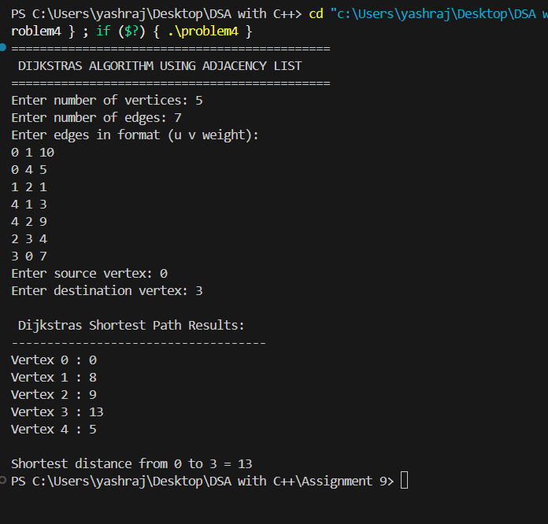

Problem 5 : Write a Program to accept a graph from a user and represent it with Adjacency List and perform BFS and DFS traversals on it.
CODE:
#include <iostream>
#include <vector>
#include <queue>
using namespace std;

class Graph {
private:
int vertices;
vector<vector<int>> adj; // Adjacency list

// Helper function for DFS (recursive)
void DFSUtil(int v, vector<bool>& visited) {
visited[v] = true;
cout << v << " ";
for (int u : adj[v])
if (!visited[u])
DFSUtil(u, visited);
}

public:
// Constructor
Graph(int v) {
vertices = v;
adj.resize(vertices);
}

// Function to add an edge
void addEdge(int u, int v) {
adj[u].push_back(v);
adj[v].push_back(u); // For undirected graph
}

// Display adjacency list
void displayGraph() {
cout << "\n Adjacency List Representation:\n";
cout << "----------------------------------\n";
for (int i = 0; i < vertices; i++) {
cout << i << " -> ";
for (int j : adj[i])
cout << j << " ";
cout << endl;
}
}

// Perform BFS traversal
void BFS(int start) {
vector<bool> visited(vertices, false);
queue<int> q;

visited[start] = true;
q.push(start);

cout << "\nBFS Traversal starting from vertex " << start << ": ";
while (!q.empty()) {
int v = q.front();
q.pop();
cout << v << " ";

for (int u : adj[v]) {
if (!visited[u]) {
visited[u] = true;
q.push(u);
}
}
}
cout << endl;
}

// Perform DFS traversal
void DFS(int start) {
vector<bool> visited(vertices, false);
cout << "\nDFS Traversal starting from vertex " << start << ": ";
DFSUtil(start, visited);
cout << endl;
}
};
// ================= MAIN FUNCTION =================
int main() {
int v, e, u, w, start;
cout << "=============================================\n";
cout << " GRAPH REPRESENTATION USING ADJACENCY LIST\n";
cout << " BFS AND DFS TRAVERSALS\n";
cout << "=============================================\n";

cout << "Enter number of vertices: ";
cin >> v;
Graph g(v);
cout << "Enter number of edges: ";
cin >> e;

cout << "Enter the edges (u v):\n";
for (int i = 0; i < e; i++) {
cin >> u >> w;
g.addEdge(u, w);
}
g.displayGraph();
cout << "\nEnter starting vertex for BFS and DFS: ";
cin >> start;
g.BFS(start);
g.DFS(start);

return 0;
}

OUTPUT:
